Helping your child with their maths learning:

Multiplication:

Practise multiplication facts for the 2s, 5s and 10 times tables.
We teach that the x sign = groups of/rows of/sets of.

We use arrays to help children learn these facts.
For example;

2 x 5 = 10 (total number)
2 groups of 5
OR 2 rows of 5
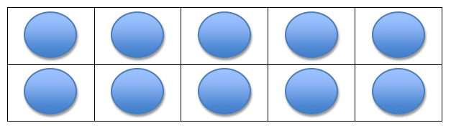

If children know that 2 x 5 = 10 they should also know:

5 x 2 = 10
5 groups of 2
OR 5 rows of 2
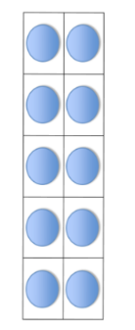
Get children to make an array with counters or pennies and when they are confident, get them to draw their own arrays on paper.
Children must practise and know all multiplication facts for these tables by the end of year 2.

Remind them that the biggest number always comes at the end of multiplication sentences.

Division:

When they are confident with multiplication, children also need to know the related division facts for the 2s, 5s and 10 times tables.

We teach the ÷ sign using 2 different methods.

- Grouping method:

÷ means the same as “put into groups of….”

15 ÷ 5 = 3
15 put into groups of 5 = 3 (number of groups)
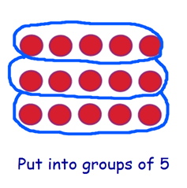

- Sharing method:

÷ also means “shared into…”

15 ÷ 5 = 3
15 shared into 5 equal groups = 3 (number in EACH group)
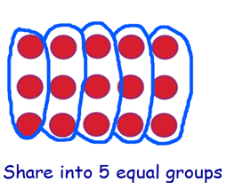

Help your child to practise both methods by using pennies, counters, or by drawing their own pictures on paper.
Remind children that the biggest number always comes first with division.
Addition:
First, we teach children to add using ten frames up to 10 and 20 (concrete stage):
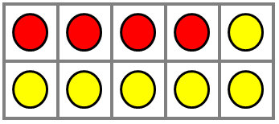
4 + 6 = 10

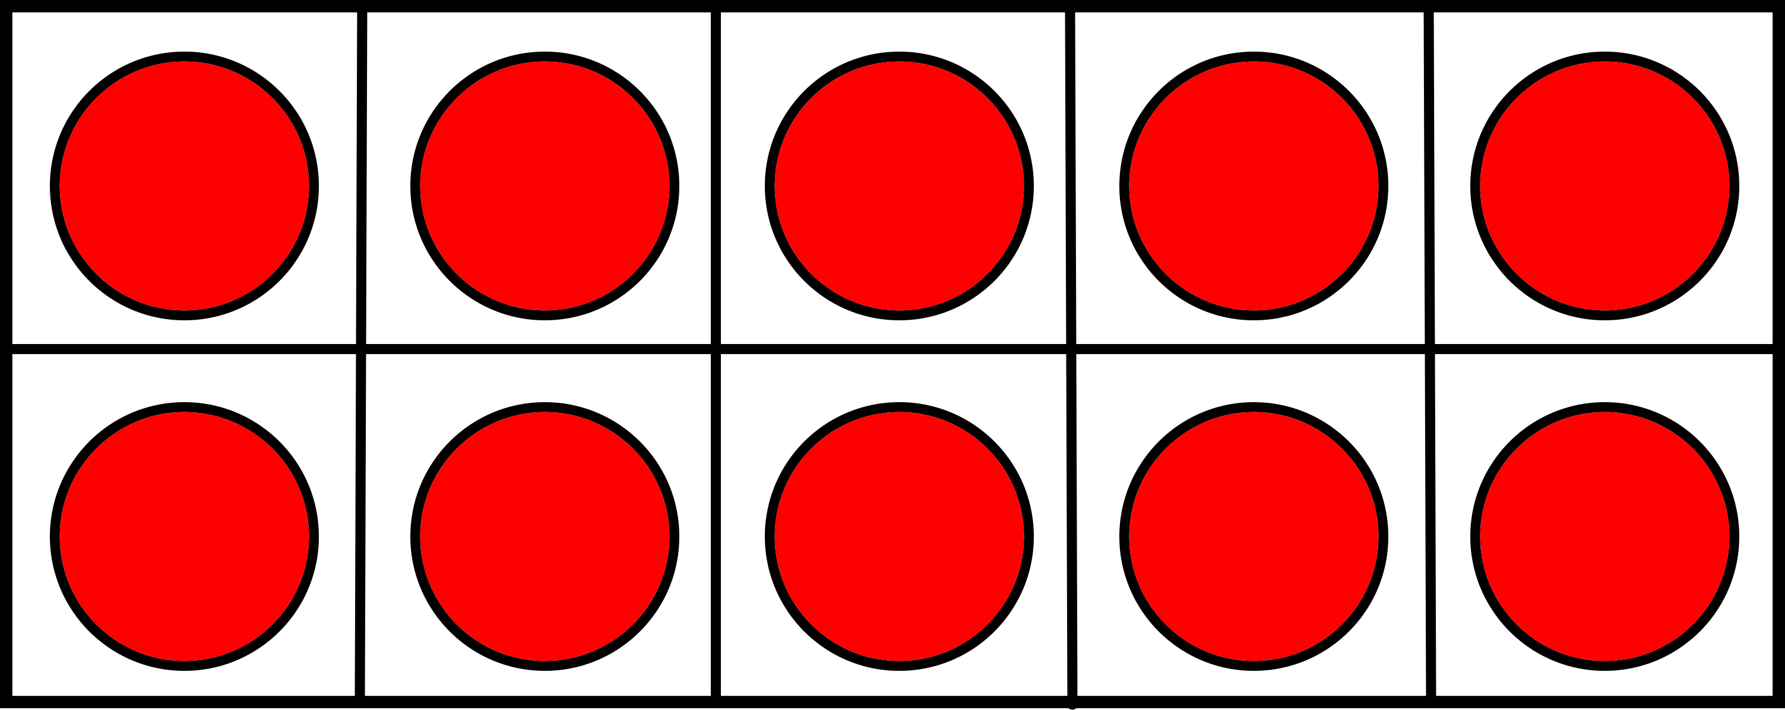
14 + 6 = 20

Then, we teach children how to add 2-digit numbers over 20 using tens and ones.
32 + 16 = 48

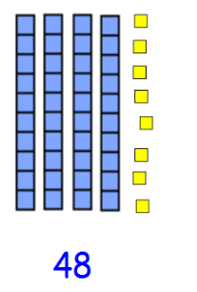
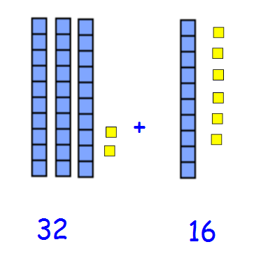

=

Children need to be confident in identifying the tens digit and the ones digit in 2-digit numbers to help with addition skills.
If you don’t have tens and ones at home, your child can use pens to represent 10 and counters or cubes to represent ones. Once children are confident solving addition problems with these resources, they can move on to drawing tens and ones (pictorial stage):
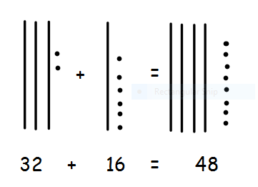

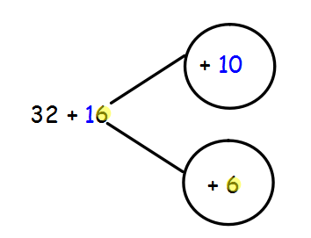
Eventually, when ready, they can move onto the part whole method, or partitioning (abstract stage).

32 + 10 = 42
42 + 6 = 48
Subtraction:
As with addition, we use the ten frames so that children can physically take away single digit numbers up to 10 and then 20 (concrete stage)
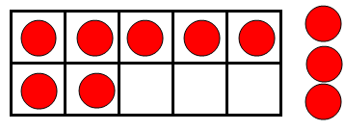
10 – 3 = 7

We then teach subtraction using tens and ones (not crossing the tens).
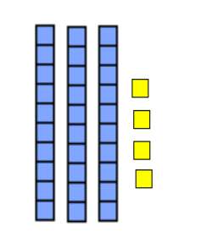
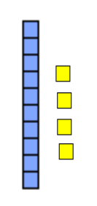
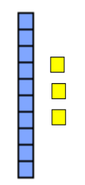

34 – 21 34 – 20 = 14 14 – 1 = 13

Children should subtract the tens first, followed by the ones.

Once children are confident with solving subtraction problems with these resources they can move on to drawing the tens and ones (not crossing the tens - pictorial):
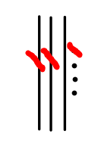

34 – 21 = 13

Once children are confident with this method they can move on to the part whole method (partitioning) to subtract 2-digit numbers crossing the tens (abstract):
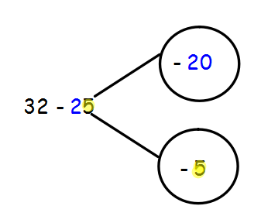

32 – 20 = 12
12 – 5 = 7

Please allow children to use resources until they are ready to attempt it without.
Please also give your child plenty of opportunities to mentally + and – single digit numbers, crossing the tens boundary. For example:
23 – 6 41 – 5 32 - 7 59 + 4

Children DO NOT need to learn the column method for addition or subtraction. This happens when they progress to Year 3.

