Woodgrange Infant School Reopening Risk Assessment June 2020
Headteacher:Sarah Soyler
Shared with:
Governors 22/5/2020
SLT 22/5/2020
Staff Y 29/5/2020

This plan addresses the issues raised on the risk assessment and gives detailed guidance of the mitigating actions.
This plan will be reviewed daily and weekly as part of our ongoing dynamic risk assessment procedures during the pandemic and in response to any increase in numbers attending school

Issue/risk area | Identified risks  (Pre populated with examples of key risks but each school will need to review its own risks) | Overall assessment of risk BEFORE mitigation  (Red/Amber/Green) | Mitigating actions  (Including who will be responsible) | Overall assessment of risk AFTER mitigation  (Red/Amber/Green) | Evidence to support assessment
Site issues (Cleaning, Catering, Equipment and suppliers) | Risk of inadequate preparations for re-opening parts of schools leads to infection or other risks e.g. cleaning  Deliveries including post | RED | Deep clean completed during closure  Shorter day - till 2.30 for reception children supports additional cleaning time  Close 1pm Fridays  Time allocated- 1 day- for reorganising rooms/ resources before opening  Time allocated for staff induction in small teams  Daily briefings/ debriefing/ updating of guidelines  PPE and additional cleaning supplies ordered and received in advance of opening  Juniper policy pack, inc RA received and incorporated into plans  Deliveries to bike shelter- site supervisor to handle after 24 hours  Box outside front door to receive post etc  FSM food parcel collection/ delivery to take place from bike shelter not EYFS play area |  | Juniper Policy pack  Staff handbook highlights and sets out cleaning regime  Staff briefing powerpoint
 | Risk of infection from parents/ visitors to school |  | No visitors to school- email/ phone contact only  If face to face contact required it takes place out of doors at an appropriate distance  Clear guidance to parents on expectations of social distancing  Gates supervised to minimise parent contactat start/ end of each sessions  Gates closed promptly  Children received in playground  If children are upset parents try to settle them outside- if not go home  Soft start 15 minute window 9-9.15 childcare group/ 9.30-9.45 reception children.  End of day reception 2.15/ 2.30 childcare 3.00  Late collections stay in class until parent arrives  New virtual procedures in place for admissions of EYFS pupils or mid phase - face time interviews/ electronic document sharing/ virtual tours of school/ zoom parent info sessions to be led by JZ
 | Risk that catering arrangements do not allow for social distancing to be maintained resulting in higher infection risk. |  | Lunches to be eaten in classrooms supervised by bubble staff  Flexible lunch period managed by bubble staff
Staffing | High infection risk due to staff unable to maintain social distancing  High risk of infection due to staff unable to maintain social distancing as move around school or need to pass through rooms |  | Hand Washing routine as staff arrive  Visual guides to handwashing displayed across school  Adequate space allowed for staff:  - staggered breaks throughout the day  - additional staff room set up in a classroom- staff assigned to one room  - allocated toilets to reduce number sharing  regular and routine cleaning of staff spaces  health and hygiene guidance for shared spaces  induction/ training as staff rejoin the school  No off site lunch breaks  routes around the building identified- external routes to avoid passing through classrooms  internal doors open to avoid handles etc  staff wash hands before leaving base room and return to it  staff use fobs to sign in/ out  internal door propped open |  | staff handbook  daily changes- debrief pm and am briefing and SLT updates if mid day
 | Due to self-isolation, shielding and illness, there is a risk of staff shortages to safely deliver education/care to specified year groups |  | Health monitoring advice given to staff  Staff availability ascertained as part of planning  Each group of children to be “over staffed” to allow for absence/ loss of availability  Phased return delays return of some staff  Ongoing daily review/ weekly reviews to risk assess ongoing situation  Consider closing or reducing numbers of children if staff levels not at a safe level |  | Staff rota  minutes of review meetings  amended rotas if applicable
 | Risk that staff cannot safely travel to work which results in staff shortages or higher infection levels |  | Staff availability ascertained as part of planning  Each group of children to be “over staffed” to allow for absence/ loss of availability  Where possible staff who drive/ walk/ cycle will be prioritised to work on site and those who cannot to work from home  Parking restrictions suspended enabling more staff to drive (check this)/ poss use of section of playground for overflow parking  Allow shorter working day for those who use TfL to avoid peak travel times- included in planning bubbles  Ongoing daily review/ weekly reviews to risk assess ongoing situation  consider closing or reducing numbers of children if staff levels not at a safe level |  | Audit of staff travel  staff rota
 | High proportion of BAME staff at higher risk of infection leads to greater staff shortages |  | Staff availability ascertained as part of planning  Each group of children to be “over staffed” to allow for absence/ loss of availability  Assessment of staff profile indicates that sufficient staff available to safely manage a slow and safe start to reopening school.  Any staff, particularly BAME staff with underlying health conditions will be deployed to work from home where possible or at school in roles that do not pose the highest risk e.g. not administering 1st aid/ intimate care. This will be in consultation with individuals and based on individual risk assessments  PPE is available to staff who wish to wear it  Ongoing daily review/ weekly reviews to risk assess ongoing situation  consider closing or reducing numbers of children if staff levels not at a safe level
 | Risk of infection to staff related to young children’s ability to follow social distancing rules and in meeting intimate care needs |  | Training for children in hand washing, avoiding close contact etc  Staff to avoid close contact with children- keep distance, sit to side not face on, avoid talking at eye level  PPE for intimate care needs  regular cleaning and hand washing regime
Pupils attending school | High infection risk due to pupils and staff unable to maintain social distancing - through not being able to keep small groups apart |  | Children will be in small stable groups with same team of adults.  Strict limits on numbers in each classroom  Oak/ Beech/ Hawthorn/ Willow/ Rowan 10 chn  Nursery 15  Elm/ Lime/ Holly 12  Classes will not mix indoors  zoned space in outdoor area limits mixing  Numbers using outdoor space will be limited and access staggered through the day.  Staggered lunchtimes and segregated play areas  Regular handwashing and cleaning of frequently touched surfaces  Allocated toilets
 | Risk site is not big enough to offer learning to specified year groups in line with DfE guidance on social distancing measures |  | Audit of school site confirms it is not big enough to accommodate all year groups.  Phased return will focus on key worker children followed by groups of Reception children only.  An upper limit will be placed on numbers UNTIL guidance on social distancing is lifted or changed significantly.  Ongoing evaluation of what is on offer
 | High infection risk due to pupils not following handwashing guidance |  | Control measures in place- routine frequent handwashing- staff will monitor and regulate this  Parents will be given time to prepare children for this regime
 | High infection risks due to pupils not moving around school at safe distance from other groups |  | Restrict moving around school- use adjacent toilets  No unsupervised movement around the school  separate play areas for identified groups  separate gates/ 1 way system for drop off and collection  Staggered start and finish times
 | High proportion of BAME pupils and higher risk of infection within some communities |  | Robust cleaning and hygiene routines  Attendance at school will be optional  Advice will be given to individual families upon request
 | Risk of transmission from clothing if school uniform and staff dress codes are enforced |  | Uniform remains optional  Children and staff will be required to wear fresh clothes each day  Information about likely life spans of virus on different surfaces available to staff
 | Risk of transmission during the conduct of practical activities in school |  | Hard to clean materials and equipment will be removed from classrooms  Thorough and regular cleaning of frequently touched surfaces by classroom staff wearing gloves  Rotation of some resources- taken out of circulation for recommended time  Staff involvement in identifying safe/ unsafe activities as part of planning process.  Sensory and tactile materials single use or not in use
 | Risk of students spreading infection deliberately (e.g. deliberately coughing on other students or staff) |  | Children are young and will therefore be closely supervised  They will have regular reminders of expectations of behaviour  Children who deliberately or repeatedly do this, or cannot help themselves will be sent home. This will be treated as an exclusion.  Guidance to parents sets out expectations
Journeys to and from school | High infection risk due to parents and/or pupils not observing social distancing on journeys to and from school |  | Clear guidance and regular reminders for parents as part of preparation  One way system for entry/ exit supervised by SLT  Low numbers in attendance  Staggered start/ end times  playground closed promptly at end of day  children do not use public transport
Fire Safety | Risk of unsafe fire management practice due to staff shortages |  | Higher than normal staff ratio  Staff induction  Additional staff briefed on fire marshall training  Fire drill in first week of reopening  regular drills as additional staff/ children return to school
First Aid and Pupils with Medical Conditions | Risk that first aid arrangements and equipment do not provide adequate protection for staff against infection |  | Each group will have individual first aid kits  First aid will be administered in class to avoid movement around school  PPE available in each room as part of kit  Guidance to staff about infection control as part of induction
 | Risk that first aid arrangements do not provide adequate support for pupils due to staff shortages |  | High numbers of first aid trained staff exist ensuring adequate rations can be maintained  Dynamic review and risk assessment to monitor this daily/ weekly
Pupils with Special Needs | Risk the needs of pupils with complex SEND cannot be safely met in school |  | Individual RAs completed by Inclusion lead and teamwith some support from services  decision about return to school made in consultation with parents on individual basis  based on risk of infection/ risk of spreading infection/ level of support and impact on group size/ density  highest risk pupils not admitted
 | Risk the needs of pupils with complex SEND cannot be safely met out of school |  | Ongoing support for parents and activity packs sent home  Weekly follow up calls  Additional virtual sessions in planning stage
Communication | Risk that pupils and parents do not understand the new arrangements; behaviour resulting in increased infections |  | Clear guidance and regular reminders to all parties  Newsletters/ phone calls/ posters etc  Ongoing daily/ weekly reviews and RAs of situation
Staff wellbeing | Risk of mental health impacts |  | SAS counselling available  Mental health first aider available  Mindfulness coach on staff  Regular breaks throughout the day  Over staffing will allow time out of class on a rota  Team leader debriefs/ reviews daily/ weekly

Recommendation: Taking into account our analysis of risks and mitigating actions, I recommend It is not safe to open to all year groups given the size of the building and the availability of staff. The risks can be reduced by maintaining a lower number of pupils in school. Therefore the
proposal is to open up childcare for critical workers and vulnerable children, allowing capacity of accommodation and staff to expand this offer and, once established bring in small numbers of Reception children over a period of 3 weeks.

Annex – Guide to assessing risk
Impact:
This is the potential impact of the risk on the organisation should it materialise. You can use a scale between 1 and 4 to rate the impact.
Likelihood:
This is the probability of the risk occurring. You can rate the likelihood of the risk using a scale of between 1 and 4.
Risk Rating:
The current risk rating is worked out by multiplying the impact and likelihood ratings of the risk. You should then use this rating to prioritise the risk.

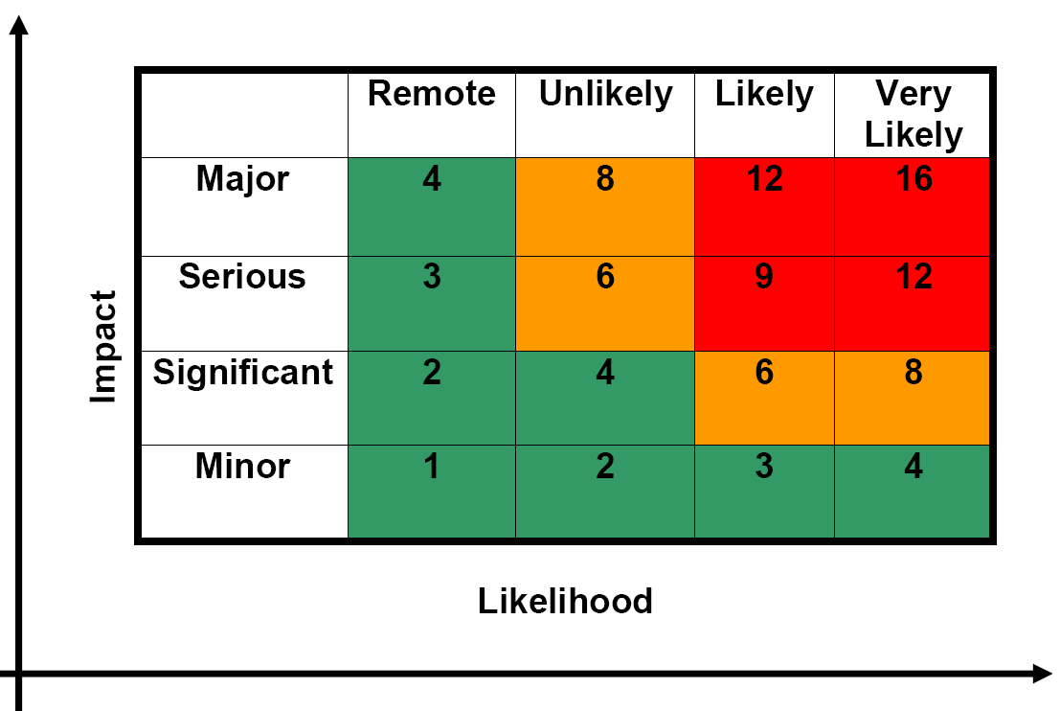

High Level Risks are risks rated 9-16 are coded RED. You should prioritise and manage these risks first.
Medium Level Risks are risks rated 6 – 8 are coded AMBER. These risks need to be managed and continually reviewed to ensure they are not posing any significant threats. Close monitoring is essential to avoid them developing into red/ high risks where possible.
Low Level Risks are the risks with the risk rating of 1 – 4 are coded GREEN. These risks require limited action but they need to be reviewed regularly to ensure they are not posing any threats.

