Reception
 | Term 1 | Term 2 | Term 3 | Term 4 | Term 5 | Term 6
 | 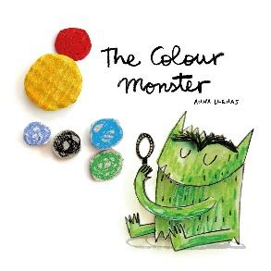  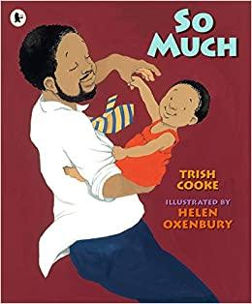 | 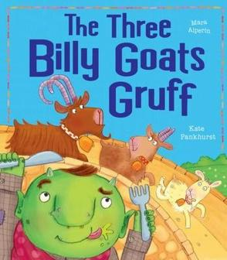 | The Giant Turnip?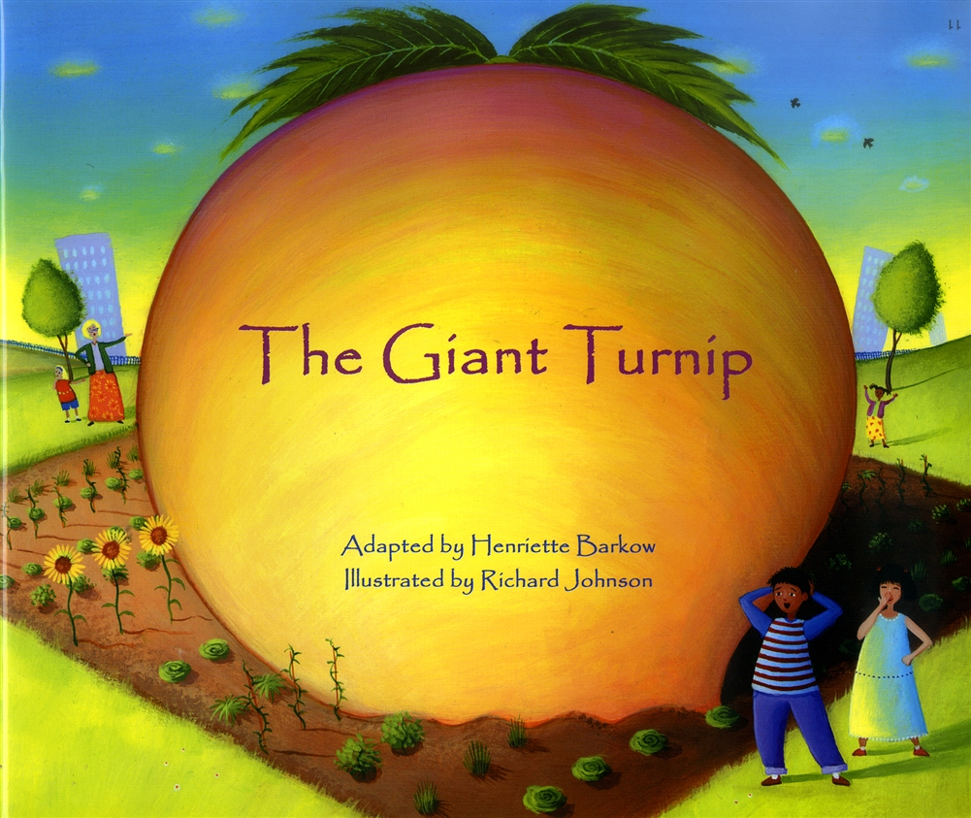 | 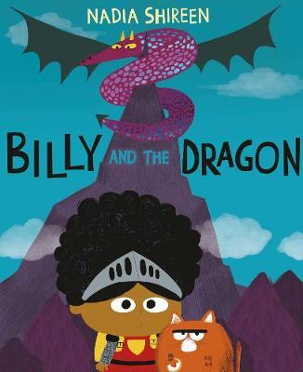  How to Light your Dragon  George & the Dragon  The paper bag princess | 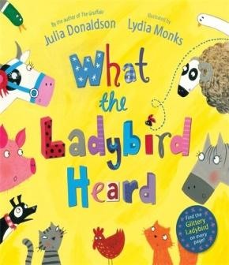  Farmer Duck  The Pig is in the Pond  Rosie’s walk | 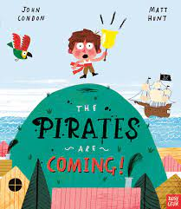
Oracy Outcome | Naming our emotions  Talking about what can help when we feel e.g. sad, scared..  Talking about our school environment, getting to know staff names and routines | How to make Troll Soup - verbal instructions |  | Chicken eggs - life cycle of a chicken  Sensory poems about chicks | Directions around the playground/ classroom  Shared storytelling - choral reading- children speak for the animals  whispering games
Vocabulary focus | Family- different terms - dad, baba etc  Emotions and feelings | Story vocabulary  Language to describe size and shape, |  |  | animals, farmyard buildings  directional language | “Pirate” language
Ed Visit/ Visitor | Journey to Forest Gate and Woodgrange event | Local Grocers (troll soup)  Diwali - dance workshop | Wanstead Flats | Magpie Park - looking for frogspawn and other spring life  Community Garden - minibeast hunt? | Mudchute City Farm | Wanstead park pirate picnic  FG community garden?  Local fish shop
Cooking | Sandwiches | Soup | Lunar New Year themed cooking, e.g. noodles and using chopsticks | Pancakes |  | Cucumber sandwiches - Jubilee party  Ice lollies for pirate picnic
Reading | Library picture books  Tales Toolkit Weekly | Sharing books  Pink books  Tales Toolkit | Pink / Red books  Tales Toolkit | Red book band  Tales Toolkit | Red book band/ Yellow  Tales Toolkit | Yellow  Tales Toolkit
Phonics | Phase 1 in groups | Phase 1/2 | Phase 1/ 2 | Phase 1/2 Or phase 3 | Phase 1/ 3 | Phase 1/ 3 consolidate
Writing  Mark making everywhere all year | Observe pencil grip and target fine motor  Learning to write name using correct letter formation | Master writing name with correct formation  Learning to write other words such as mum, dad (family members names)  Starting to represent known sounds, particularly at the end of words, e.g. kt (cat) | Writing words and a simple phase 2 sentence | Spell words by identifying sounds in them and representing the sounds with a letter or letters | Sentence structure, simple punctuation, extending ideas.  Model pencil grip and letter formation phase ⅔ and letter families  Tales Toolkit  (Thieves’) plans/ maps | Designing and making ship with junk modeling
Handwriting | Pre letter pattern handwriting song  Model pencil grip | Pre letter pattern handwriting song / practise on whiteboards / big paper etc  Model pencil grip  Handwriting learnt in phonics sessions | Generally forms letters correctly using a comfortable grip  Handwriting letter formation learnt and practised in phonics sessions and monitored during any mark making/ writing activity- child or adult initiated
UW
Dates to remember  (update for 2023) | Black History Month  24th October - Diwali | 8th November - Guru Nanak’sBirthday  14th November- Hanukkah begins  25th December - Christmas | Tuesday 1st Feb- lunarNew year | 1st March - Shrove Tues  3rd Mar- World Book day  8th March - international Women’s day (March 27th Mothers’ Day)  17th April - Easter | May 2nd - Eid  18th June Fathers’ day | Eid 10th July  sports day  Queens Jubillee afternoon tea 10th June
People, Culture & Communities  ELGs:  - Describe their immediate environment using knowledge from observation, discussion, stories, non-fiction texts and maps;  - Know some similarities and differences between different religious and cultural communities in this country, drawing on their experiences and what has been read in class;  - Explain some similarities and differences between life in this country and life in other countries, drawing on knowledge from stories, non-fiction texts and – when appropriate – maps. | Finding my way around the school (immediate environment)  Who is in my family - use photos as a stimulus. Children to bring in baby photo  Journey to Forest Gate project with families  Diwali - diya lamps making, discussion around the celebration | Following a map to the grocery shop  Special times for me and my family – what we celebrate  Guru Nanak’s Birthday  Christmas performance and workshop with families | Friendship – how can we be good friends?  Cooking - Chinese dish, e.g. vegetable noodles, using chopsticks | Shrove Tuesday - making pancakes - why do we make pancakes? | Easter & Ramadan  Caring for nature  Salt dough animals  Role of the farmer. Modern farming.  Why are animals important?  look after hens
The Natural World  ELGs:  - Explore the natural world around them, making observations and drawing pictures of animals and plants - Know some similarities and differences between the natural world around them and contrasting environments, drawing on their experiences and what has been read in class  - Understand some important processes and changes in the natural world around them, including the seasons and changing states of matter. | Me now – my height etc  Autumn discussions and how our Reception trees change over time.  Autumn watch home learning - bring something autumnal in from home  EYFS chickens - children take turns to look after them - what extra things do they need as the seasons change, e.g. straw for warmth as weather changes (throughout year observe and discuss) | All about Goats! Where else do goats live?  Grocers - local environment - talking about what we know about where we live and our home within Forest Gate  Planting bulbs ready for spring, e.g. tulip, daffodils | Make fat balls to feed birds in depth of winter | Drawing animals from book that go to the party from pictures  (hedgehog, squirrel, bunny, rabbit fox, cat, mice)  Look at the setting of the book. The deep dark forest. How does it compare to Forest Gate?  Look at images of what Forest Gate used to look like?  changes to school grounds- blossom/ buds | How people travel around, including to work  How I’ve changed since beginning school; what I’ve learnt to do.  Do the same with animals.  Life in different environments.  What do animals eat?  Similarities and differences?  How environments differ; link to Mudchute visit - city vs farm. Observing environments from DLR train) | What lives in the sea?  Float and sink, making boats
Past and Present  ELGs:  - Talk about the lives of the people around them and their roles in society - Know some similarities and differences between things in the past and now, drawing on their experiences and what has been read in class  - Understand the past through settings, characters and events encountered in books read in class and storytelling; | Family photos, baby photos  Journey to Forest Gate project with families resulting in exhibition | Shopkeeper roles and other people who help to give us food - farmers etc |  | Mothers’ event | Fathers’ event | Different types of boat and ships  Moving boats using air
Creative
Artists/ Art  Take every opportunity to develop gross and fine motor control and dexterity and to practise pre letter shapes on different scales, surfaces and with different tools and materials |  | Mark making with different tools/ brushes on sticks- dark and light colours  Black and white patterns- paint/ draw/ cut (pre letter patterns)  Fireworks pictures  Mark making to music of different tempos of music | Picasso- constellations- dot to dot patterns  O’keefe- starry sky  Kandinsky- collage of circles | Easter eggs, nests, eggs using split pins. | Matisse snail-Artist  Mud painting-Richard Long (textures) Printing plates outside, monoprints.  Landscapes using shapes and collage to create a farmyard. Picasso, Paul Klee, | Using watercolours, thin paint- blow painting,  Bubble printing  Finger painting wave patterns  Weaving  Collage using blue materials  Flag making using their faces
Music |  | Learning through music programme Songs for Winter / Christmas performance |  | chick , chick, chick, chick, chicken Responding to music as different animals. | animal songs - OLd Mac Donald | Sea songs and shanties  The big ship sails etc  Row row row the boat  Barefoot books - pirates life for me
Celebration of learning | Family journey display | Winter show  family making workshop | Making soup video |  |  | Pirate picnic Art exhibition  Dress up as pirates

