Year 1
Term | 1 | 2 | 3 | 4 | 5 | 6
Core book | 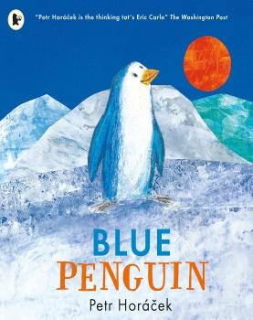 | 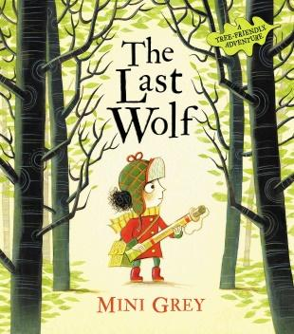 | 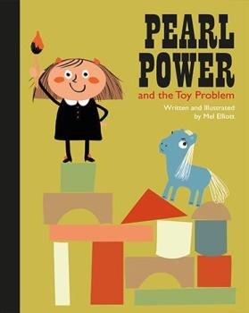 | 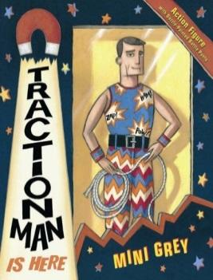 | 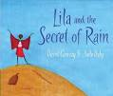 | 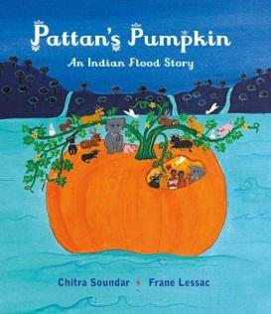
SEN Text |  |  |  |  | Handa’s surprise | The Runaway Chapati?
Supporting  text |  |  | 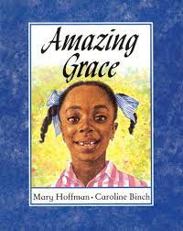
non fiction | Penguins/ Antarctica | Hedgehogs (non fiction) | Malala Yousafzai  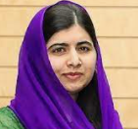 | Toys | African habitats/ animals | Weather  plants
oracy | Oral retelling of story | Hedgehog documentary | Speech making/ debate  Interviews | Parent performance (play)  Emergency phone call |  | Weather reports
writing | Stories | Questions | Letters | stories |  | stories
Ed Visit/ visitor | Fish shop | Pantomime |  | Wanstead Park (bluebells) |  | Thames barrier park
family event or celebration |  |  |  | International Womens’ day- link for each year group
PSHE link  EMPATHY | Belonging / loneliness | Caring for the environment | Equality/ equity | What does being a hero mean |  | Caring for living things
Science  Seasonal change/ weather throughout | Compare/ group/ Describe the properties of everyday materials- warmth  Name and recognise variety of common animals -fish/ birds  Animals suited to cold climates/ sea creatures/ fish | Naming common trees found locally- deciduous/ evergreen (Autumn/ winter)  Name and recognise variety of common animals- woodland mammals- carnivores etc  Woodland habitats- UK | Name human body parts and senses and what they do | Compare/ group/ Describe the properties of everyday materials- stretchiness/ waterproof/ strong | Planting pumpkin seeds, observing, measuring and recording growth  Observing seeds in fruit- sorting/ classifying | Naming common trees found locally- deciduous/ evergreen (Summer)  Plant out pumpkins
INVESTIGATE | Ice cube melting  floating/ sinking  Transporting water |  |  | Stretchy fabrics  Absorbent fabrics |  | Materials to make a waterproof coat/ umbrella/ damn
History | Growing up/ older- personal chronology  Use observations to suggest answers to simple questions |  |  | Toys past and present  Ask people of different generations what they used to play with |  | North Sea Flood 1953 (Canning town and Silver Town)
History  significant people | 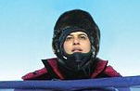  Namira Salim - first Pakistani to reach the North and South Pole.  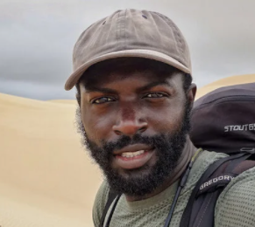  Mario Rigby - the eco explorer  Ernest Shackleton- finding Endurance in 2022 |  | 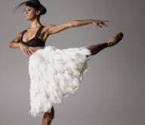  Misty Copeland - the first African American Female Principal Dancer with the American Ballet (link to Amazing Grace | 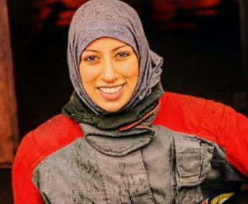  Uroosa Arshid - UK’s first hijabi firefighter  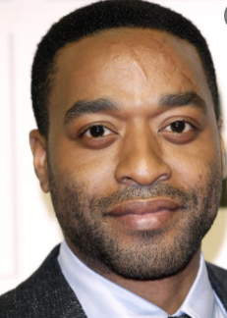  Chiwetel Ejiofor links to end of term performance/acting
Geography | Sense of globe- poles  Antarctic  Seas and oceans  Continents  Answer questions from pictures and text | 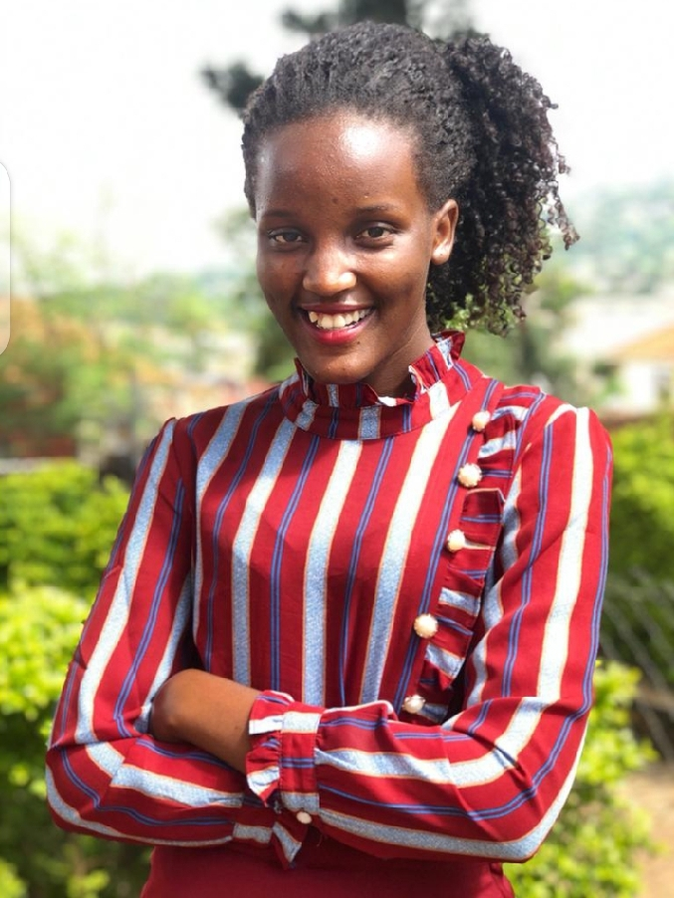  Vanessa Nakate, Ugandan climate activist | Understand simple maps  Where we live | Name UK countries  Countries of UK  Taste regional food from the four countries.  Location of royal palaces | Compare weather from winter to summer | Sense of where other countries are and how they differ  Explore settings of stories- India (position in the world)  Use geographical vocabulary  Compare to UK
Art | Arctic scene- cold colours  Icelandic artist Olaf  clay penguins | Mixing colours- shades of green  William Morris  Observational drawings - Autumn leaves  Woodland scene- warm colours  Natural materials | Natural collage - Goldsworthy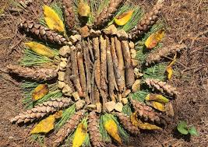 | Andy Warhol self Portraits  or Traction man portraits  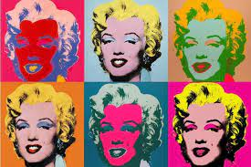  Roy Lichtenstein- pop art | 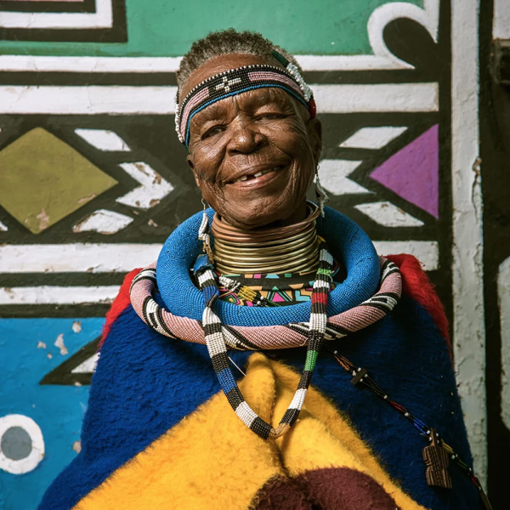  Esther Mahlangu, South African artist  primary colours  tessellation/ symmetry | 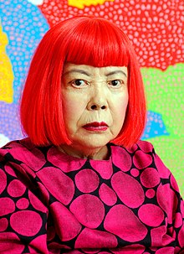  Yakoi Kusama, Japanese artist  Pumpkin  Observational drawings- pumpkins  Block printing
DESIGN TECH | Mittens for an arctic explorer |  | Wooden house for a hedgehog | Postbag | Moving picture  levers/ sliders/ pivots | Design and make a structure to keep water out- damn/ flood barrier  Pumpkin salad
Computing
RE | What can be special about living with family and friends? | What does it mean to belong to Christianity? | How do Christians celebrate Christmas? | What does it mean to belong to Sikhism? | What does it mean to belong to Hinduism? | What does it mean to belong to Islam?

