Year 2
 | Term 1 | Term 2 | Term 3 | Term 4 | Term 5 | Term 6
Core book | 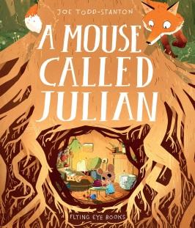 | 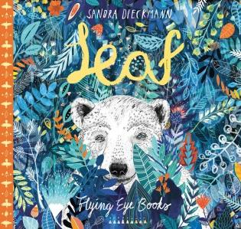 | 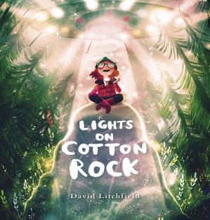 | 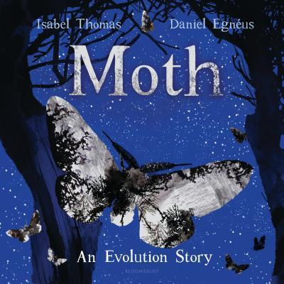 | 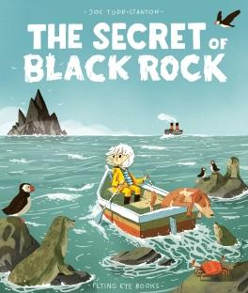 | 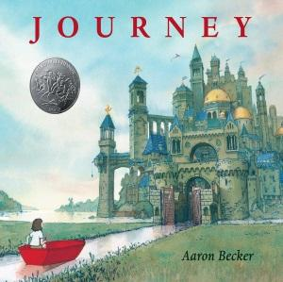
SEN group book |  |  |  | The Very Hungry Caterpillar
Supporting  text | Fox and the star, The lion inside  Fantastic Mr Fox | Fox, Robot and the Bluebird, The Lonely Beast, The Journey Home | The darkest dark | The building boy | Hello Lighthouse | Grey Island Red Boat
non fiction | British Woodland animals | Polar Bears | Space | Minibeasts  Life cycles | Under sea habitats  Grace Darling | Castles
oracy | Advert for soup | Present the poem | News Report  Aliens have been spotted. | Speech about improving Forest Gate local environment | Speech about plastic in the ocean | Performance - storytelling
writing | Tales Toolkit story | Poetry | Create own alien story | Non-chronological report | Write a letter to the author | Text to accompany book
PSHE | Class “rules”  Colour monster  BHM | Refugee  Feeling lonely/ Making friends | Family  No place like home | Caring for living things | Caring for others & environment | Transitions
Ed Visit/ visitor | Wanstead Flats- habitats | Magpie project volunteer | Greenwich Observatory  (Sci/ Hist/ Geog) | East Ham Nature Reserve  Natural History Museum  Visit to Greenwich/city (London skyline.) | Fish shop  RNLI visitor  Leigh-on-Sea/ Chalkwell | London visit- buildings and architecture  Tower of London?  Canary Wharf?
annual event or celebration |  |  |  | International Womens’ day- link for each year group
Science | Plant a bulb  British Woodland Food chains  Identify animals that are carnivore, omnivore, herbivore  Notice that animals, including humans, have offspring which grow into adults.  Importance of right food/ exercise/ healthy lifestyle  Where do animals live? | Understand how to classify animals  Waterproof materials  Arctic Food chains  Identify animals that are carnivore, omnivore, herbivore  Identify and name variety of animals  Describe and compare the structure of variety of animals (fish, amphibians, reptiles, birds and mammals)  Animal habitats and adaptation  Classification of animals  Can you find the treasure? (cornerstones) | Materials  What do plants/ animals need to survive?  Could a plant live in space?  Materials suitable for making a moon buggy  (waterproof)  Why is there no life on the moon?  Find out how the shapes of solid objects made from some materials can be changed by squashing, bending, twisting and stretching.  Testing Moon Buggies on ramps with different surfaces. Predict distances, test and measure. Slowing down a falling object (parachute) | Staying healthy, strong and well  Observe/ describe how bulbs grow and mature  Identify/ classify fruit and veg  Plant seeds for flowers to attract bees and other insects  Identify and compare the suitability of a variety of everyday materials linked to designing bug hotel  Food chains - Insects  Animal habitats/ microhabitats-  differences between things that are living, dead, and things that have never been alive.  Garden pests and friends  Food chain- in the garden  Can seeds grow anywhere? (cornerstones) | Impact of humans on the environment  Importance of oceans to life on earth  Climate/ weather  Observe changes to bulb  Recycle or not?- check labels  Food chains- sea based  Climate change/ pollution of seas  Plastic in the oceans  Exploring underwater habitats  Cornerstone ‘why do boats float?’  Cornerstone ‘Will it degrade?’  Evaluating both experiments. | Materials  What materials would be best for a bridge?  Cornerstone ‘Can you make a bridge?’
HISTORY | Understand what significant means and say why some people are significant | Use information sources to learn about a recent event | develop a Timeline (space travel) significant events | Use artefacts to ask and answer questions about the past. | Understand what significant means and say why some people are significant
PEOPLE  EVENTS- LOCAL  EVENTS- NATIONAL/ INTERNATIONAL | Juliet Sargeant - British Garden Designer 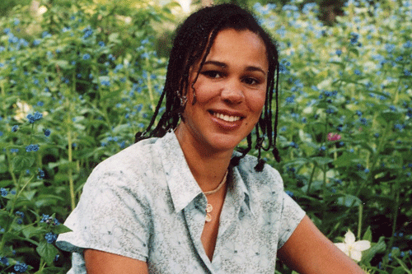  Nadia Hussian - British chef  Jaimie Oliver - British Chef  Michael Caines - British Chef. | Arctic explorers incl Matthew henson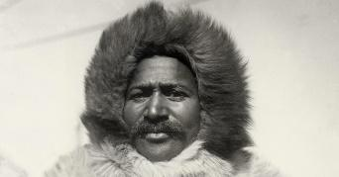  First women - Ingrid Christensen  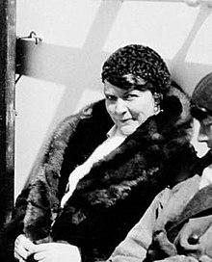  Climate change protests | Valentina Tereshkova  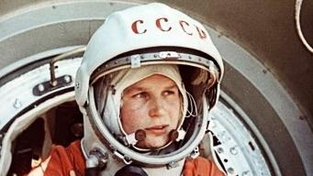  Mae Jemison  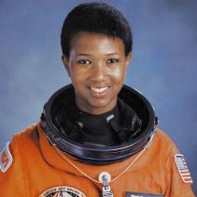  Tim Peake  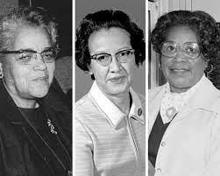  Dorothy Vaughan, Katherine Johnson and Mary Jackson – Nasa engineers  Moon landings | 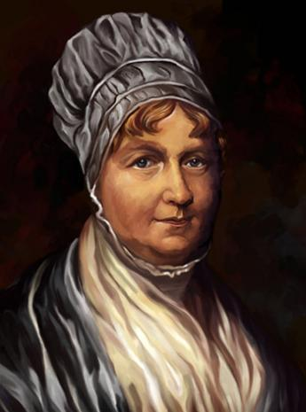  Elizabeth Fry – A campaigner (link to Magpie Close) Magpie Park- work house fire etc- Local history  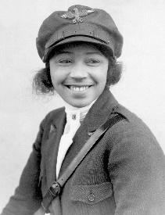  Bessie Coleman – First African-American female pilot  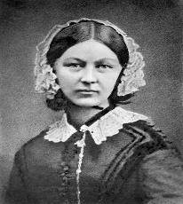  Florence Nightingale – a nurse and social reformer  How has the local area changed?  Local walk- how is the High Street changing?  Compare to old photos. (Using historical sources) | Greta Thurnburg  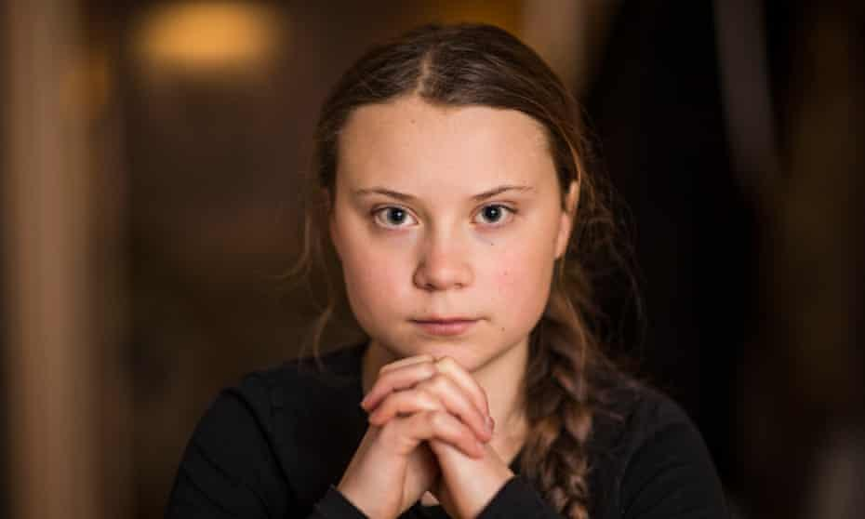  David Attenborough  Grace Darling  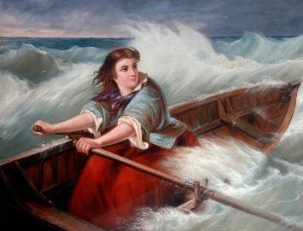 | Olympics (2012- 2020)  Athletes- local heroes  Christine Ohuruogu  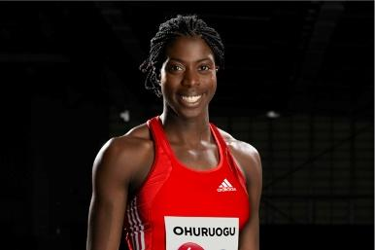  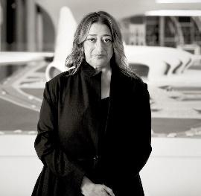  Zaha Hadid – Architect
GEOG | Maps and mapping  Woods and forests  Maps with keys and compass points  Seasonal change- summer- autumn | Habitats in different parts of the world  Home - Forest Gate  Locate places, including oceans and continents using maps and atlases  Compass directions (N/S/E/W)  Impact on forests - deforestation  Daily weather- data handling  Climate change | Use and understand aerial photos and maps  Earth from space  Aerial photos of local area  Google earth  Use aerial photos and a plan to recognise  landmarks and physical features  Seasonal change- winter | Sense of where we live- investigate local places  London  Name, locate and identify characteristics of the 4 countries of the UK, their capital cities and surrounding seas  Spring | Sense of far away places and how they differ  Oceans & seas  Climate  Use geographical vocab- Impact of humans on the environment  Weather in different locations studied  Climate change | Sense of far away places and how they differ  Oceans & seas  Climate
ART | Observational drawing/ painting of vegetables  Watercolour paint Observational drawing of vegetables  Book Marks  Running stitch | Matisse- leaf cuts  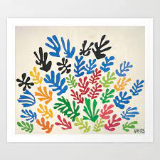 | Van Gogh Starry Night  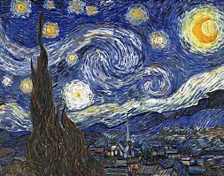  Explore lines and patterns  Clay aliens  Alien finger puppets  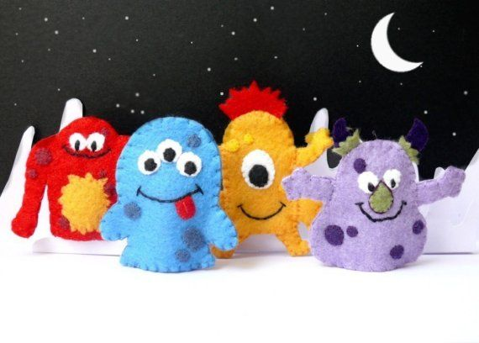 | J S Lowry  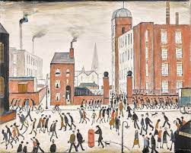  Watercolour paintings  Observational drawings of moths -Improving and redrafting (charcoal) | John Kindness - Big Blue Fish (Belfast)  Observational drawings of fish  Watercolour fish  Recycled sculptures in the style of Phyllida Barlow 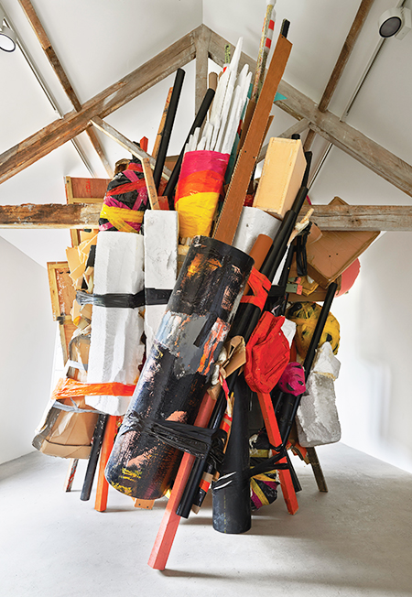 | 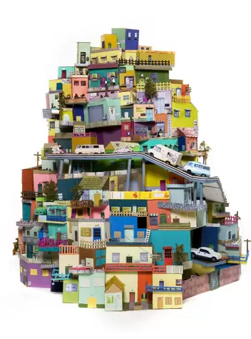  Shoe box city  Design and make a magic carpet  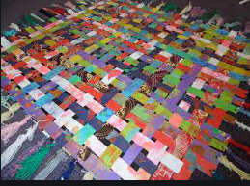  Weaving
D T | Joining materials- sewing design a book mark |  | Moon Buggies | Bug hotel / bird box |  | Explore and use mechanisms.
Computing
RE | Why did Jesus tell stories? | Why are different books special for different people? | Forgiveness: What does it mean to say sorry? | Why is Easter important to Christians? | How does special food and fasting help people in their faith? (all religions) | Where did the world come from and how should we look after it?

